## **Plus W IT training class 5.**

# Task 3

* AWS instance is launched.



* Connecting to instance using git

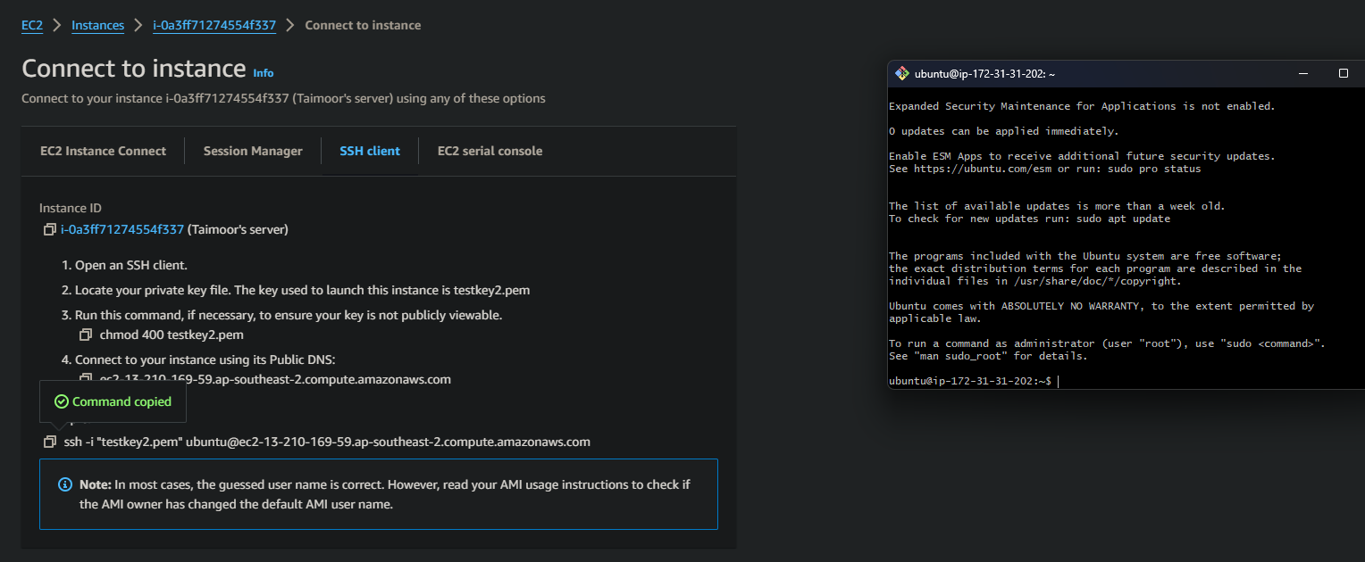

* The to do list repository is cloned on my local instance

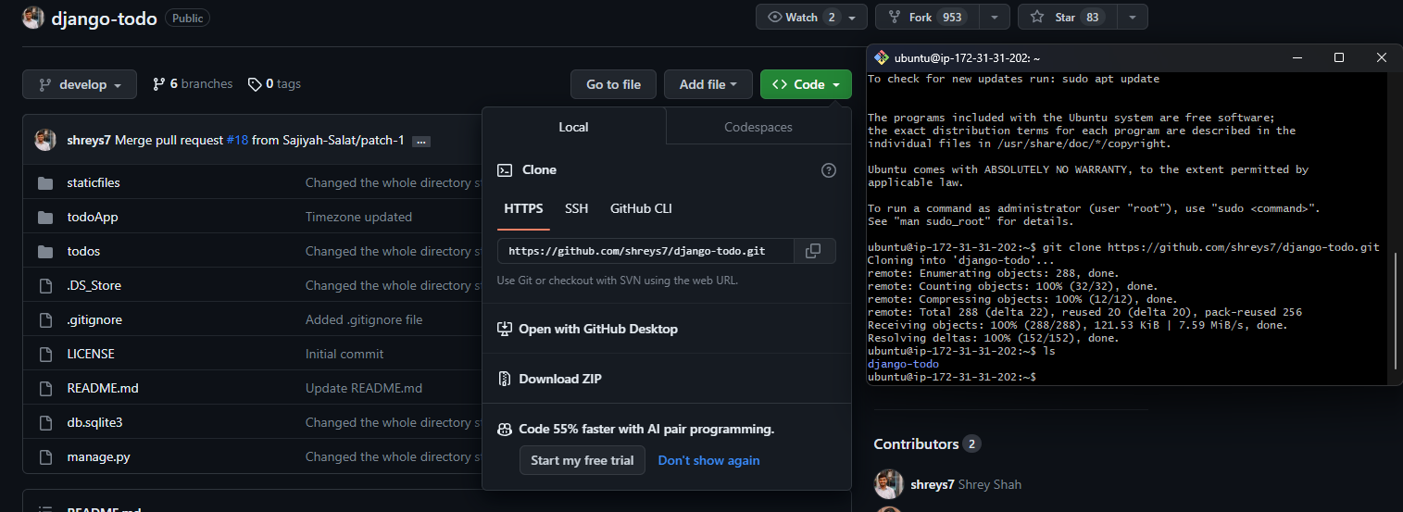

# Manual Steps for deploying the Django application

* After installing all the necessary components such as pip and Django, using migration command to manage database schema

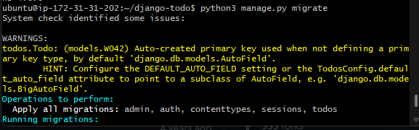

* Before running the server on 8001 port, going to settings.py file to make changes so that our web server runs

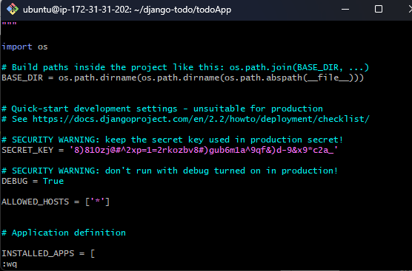

* Next going to security in AWS instance security section and adding our port to security group and setting it so that it can be accessed from anywhere publicly

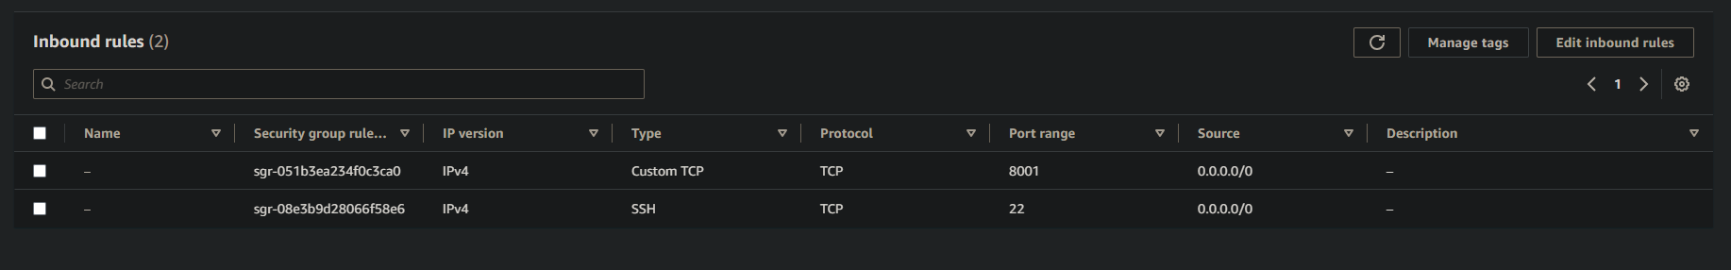

* Finally running the server on 0.0.0.0:8001 IP so that it is available publicly. As you can see our web server is running successfully.

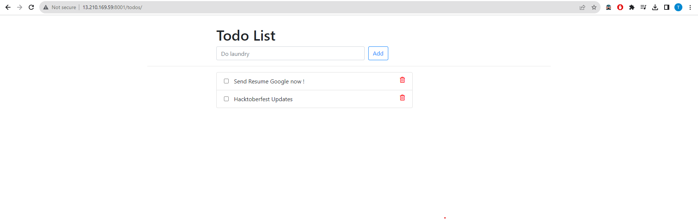

# Using docker to deploying the Django web server

* After installing docker, creating a docker file which will automate the steps to deploy the django server

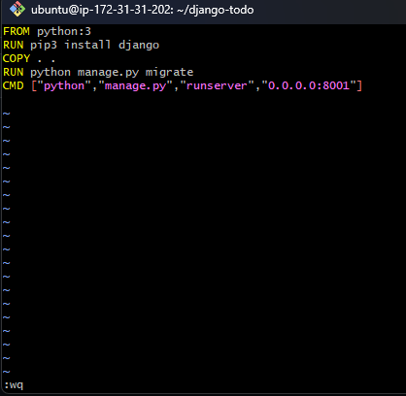

* Docker file is successfully built



* Finally through docker our django web application is also deployed

